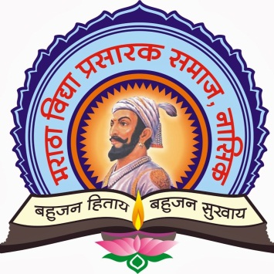

**MVPS’s**

**RAJARSHI SHAHU MAHARAJ POLYTECHNIC,**

**NASIK**

**COMPUTER TECHNOLOGY DEPARTMENT**

**ACADEMIC YEAR 2021-22**

**SOFTWARE TESTING (22518)**

MICRO-PROJECT

ON

**“ Text Editor in Java ”**

SUBMITTED BY

|  |  |  |  |
| --- | --- | --- | --- |
| **SR. NO** | **ENROLLMENT NO** | **EXAM SEAT NO** | **STUDENT NAME** |
| 1 | 1910020362 | 215646 | Savant Omkar Vitthal |
| 2 | 1910020363 | 215647 | Sawant Diksha Pravin |
| 3 | 1910020364 | 215648 | Shimpi Om Vilas |



MAHARASHTRA STATE BOARD OF TECHNICAL EDUCATION

Certificate

This is to certify that Ms./Mr. _Savant Omkar Vitthal_____________________

Roll No.__46___ of 5th semester of Diploma in **Computer Technology** of Institute **MVPS’s Rajarshi Shahu Maharaj Polytechnic, Nasik (Code: 1002)** has successfully completed micro-project in **SOFTWARE TESTING (22518)** for academic year 2021-22 as prescribed in curriculum of MSBTE, Mumbai.

|  |  |
| --- | --- |
| Place:Nashik | Enrollment no.:1910020362 |
| Date:…………. | Exam seat no:215646 |

|  |  |  |
| --- | --- | --- |
| **Prof.P.N.Patil** | **Prof.P.D.Boraste** | **Dr. D. B. Uphade** |
| **Course Teacher/Guide** | **H.O.D** | **Principal** |